***THRIFT FASHION STORE***

***August 2022***

***Version 1.0***

***TECHWIZ 3***

1. **Introduction** 
   1. Scope and Purpose

Website titled Fashion Shopping Fashion Reimagined. It helps prevent old clothes from being thrown away and provides affordable clothing to individuals who can't afford to buy new completely.

1.2 Topic Goal

• Build Website sales Thrift Fashion.

• Research on technology to develop Website JavaScript, html, css.

1. System Functions:

* Function to view product information:

This feature helps us to view product information including name product price, size, rating of the person who bought the product color, discount, add to cart and buy online.

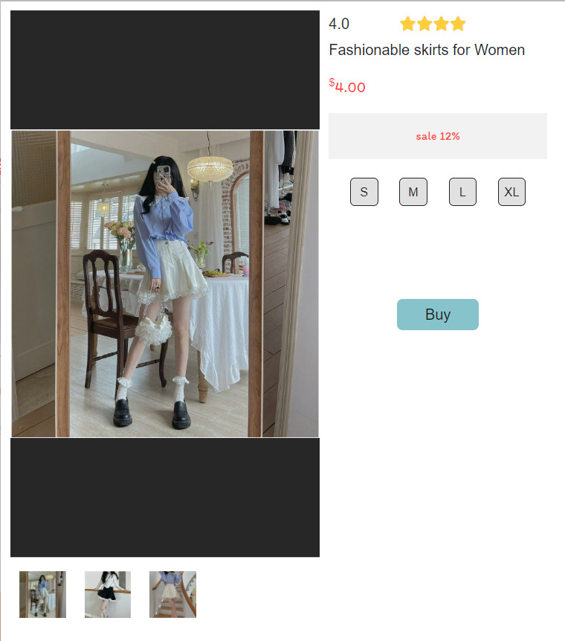

* Product search function:

This feature helps you find the product user want easily. By entering the name of the product you want and pressing search, they will find the product you want find.

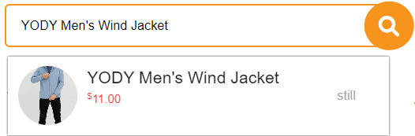

* Function to use shopping cart:

The shopping cart has a feature that helps user see the products you want to buy, provide detailed information about the product, the number of products you want to buy, the total amount you need to pay.

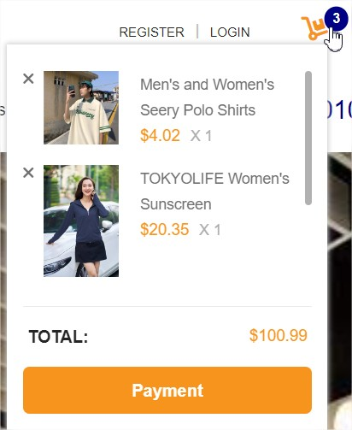

1. Display

* Home page:

Welcome users to the shop through the homepage interface. Home Fashion has a lot of attractive features, a beautiful product catalog and is on sale

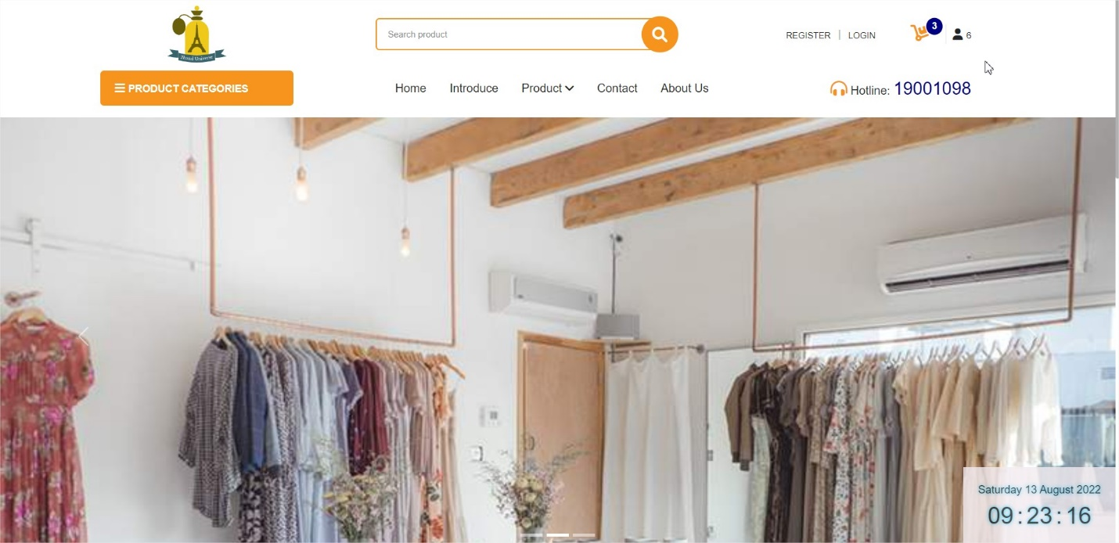

* Products:

where users can browse through fashion models and find their favorite outfit

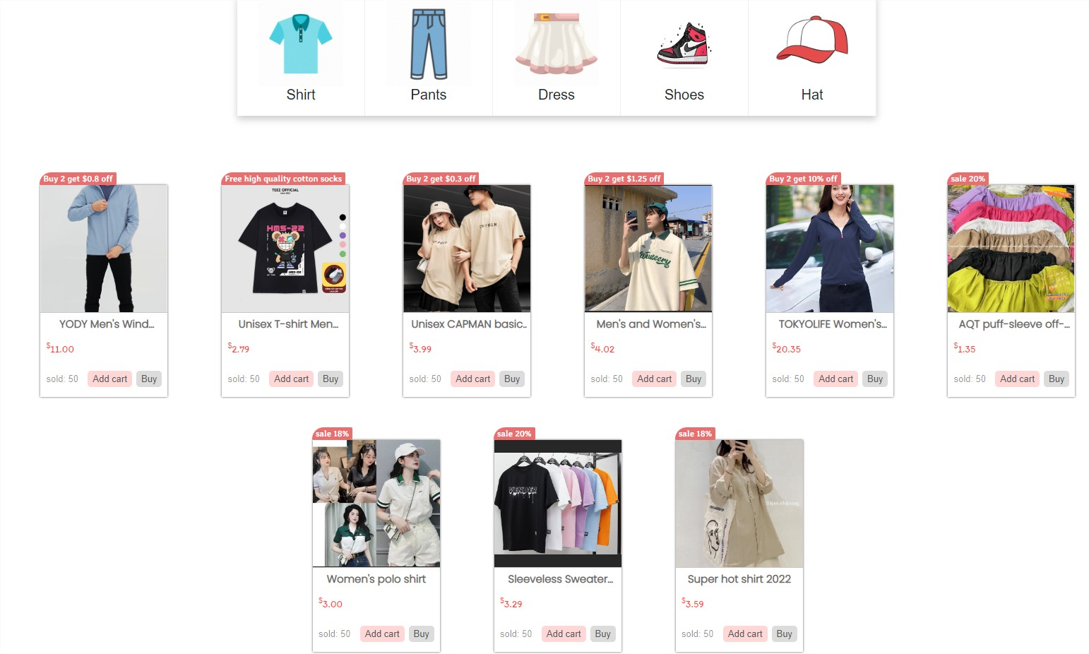

* Find Products:

You can find products you like here

The shop will filter and give users the exact same or similar clothes as the one them need

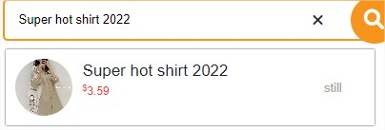

* Check out:

Users can view the products they have selected during the shopping process at the store, they can order or cancel the fashion models that they do not like.



* About us and Contact us:

Users can find out more information about the shop and contact the shop directly through About us and Contact us

About us:

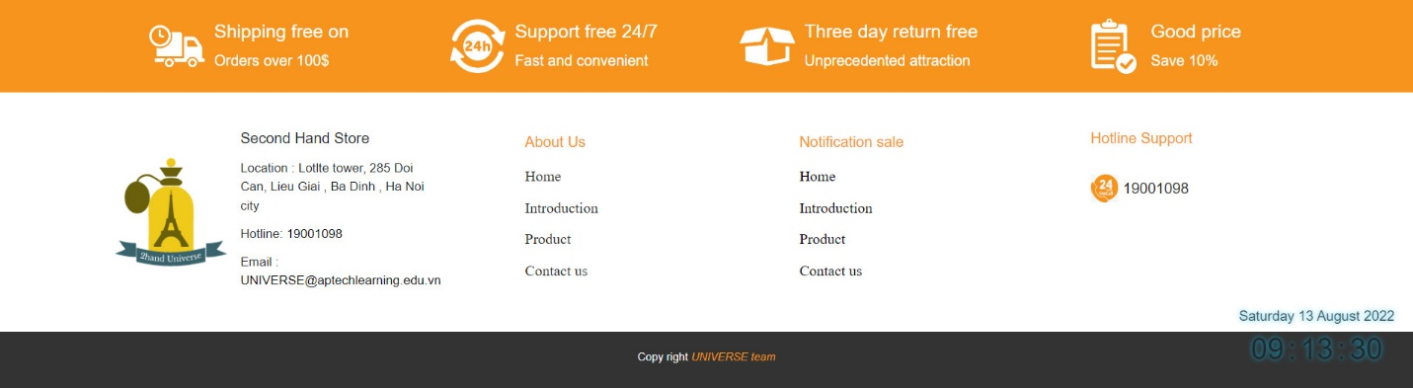

Contact us

* Visitors:

Allows users to see the number of visits to the shop



* Tickers:

Show current time to user

